**CSE3215**

**Quiz 3 (Set A1)**

**Time: 20 minutes**

**Marks: 10**

* 1. If your system is 3.3V and your 10-bit ADC is reporting 512, what is the analog voltage measured? (2)
  2. (3)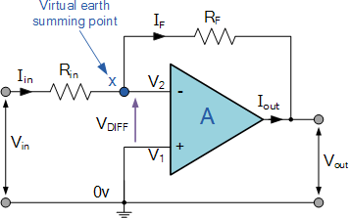

For the above figure, let RF = 250 kΩ, Rin = 10 kΩ and Vin = -0.5V. Calculate I, the voltage across RF, and Vo.

* 1. A DAC is showing 550V output for the input code 010101. Calculate the LSB and Reference voltage if it operates within 200V to 800V. (2)
  2. Write down the characteristics of an Ideal OpAmp. (3)